*BERLIN BROTHERSVALLEY SCHOOL DISTRICT*

*1025 MAIN STREET*

*BERLIN, PENNSYLVANIA 15530-1498*

*814-267-4621 • FAX: 814-267-6060*

“HOME OF THE MOUNTAINEERS”

Dr. David F. Reeder Lori Gindlesperger

*Superintendent* *Business Manager*

**Instruction for the 3 Clearances Required by Act 153**

*If you do not have internet access, or you would like to submit Act 34 form and/or Act 151 through the mail. Please call 267-4621 and we will forward you the paperwork.*

**1.** PENNSYLVANIA CHILD ABUSE HISTORY CLEARANCE ACT 151

**ELECTRONIC SUBMISSION –COST $13**

Child Abuse History Clearance Online: <https://www.compass.state.pa.us/CWIS>

You must create an account or log in if you already have an account. **Note: you will need an email address to create an account.** Creating an account and submitting your clearance application online will give you access to your results or the status of your results. (Choose School employee when asked what the application is for.) You will need to wait for an email stating the clearance is ready, sign back in and print it. This might take a couple of days.

**2.** ACT 34 – PA STATE CRIMINAL HISTORY CLEARANCE INFO

**ELECTRONIC SUBMISSION –COST $22**

PATCH <https://epatch.pa.gov/> Click submit New Record Check, fill out the information, follow the rest of the directions and Print a copy.

**3.** IMPORTANT ACT 114 FBI CLEARANCE INFORMATION

**ELECTRONIC SUBMISSION –COST $25.25**

Registration is online at https://uenroll.identogo.com. The attached paper will give detailed instructions as this process changed November 28, 2017.

CODE: 1KG6XN

You must register online and then go and get your fingerprints taken.

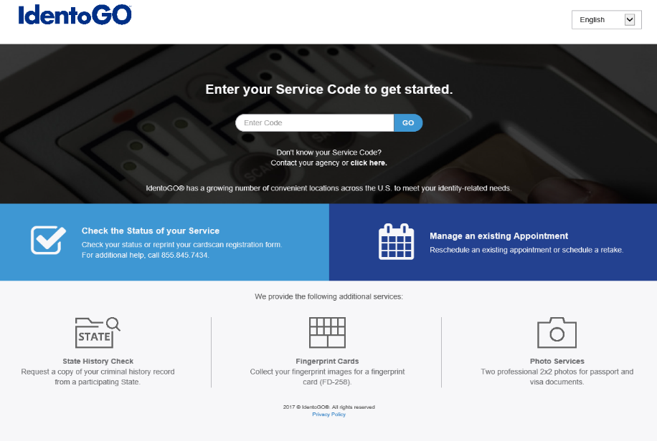

FBI FINGERPRINT CLEARANCE

Effective November 28, 2017 the PDE has changed vendors for FBI fingerprint clearance processing from Cogent to IDEMIA.

<https://uenroll.identogo.com/>

Cost is $22.60

Registration is required in order to have fingerprints taken.

1. Go to IDEMIA’s website:

<https://uenroll.identogo.com/>

1. Enter Service Code “1KG6XN”
2. Press Continue
3. Select Schedule or Manager Appointment
4. Enter Name, Birthdate, Email and Phone number

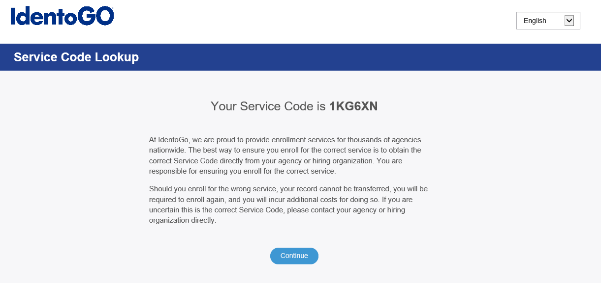

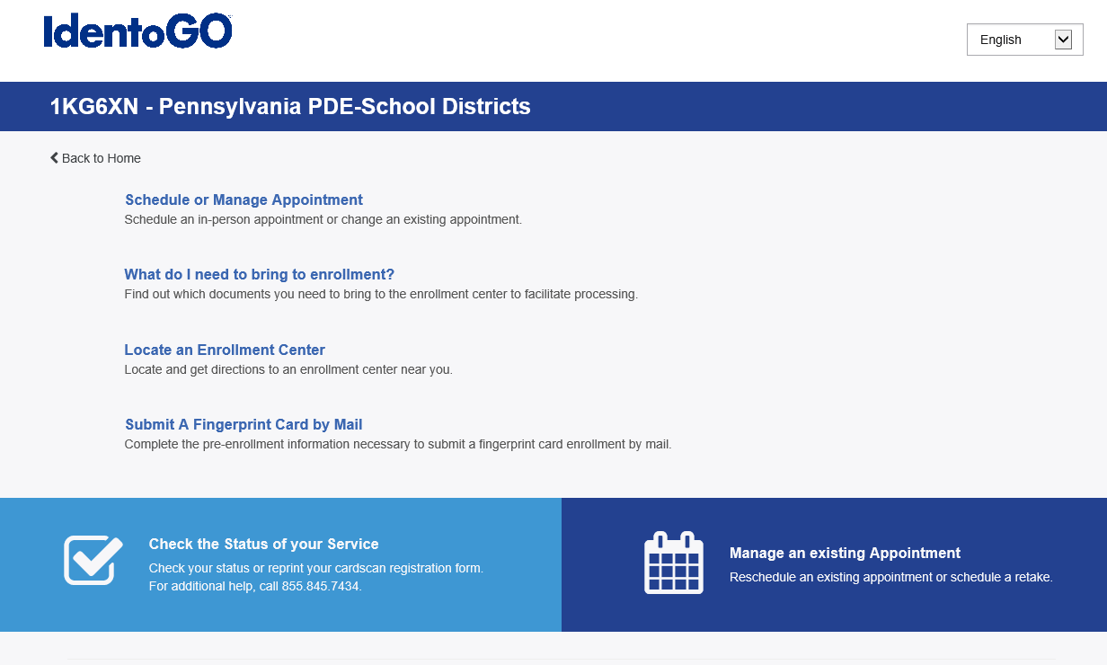

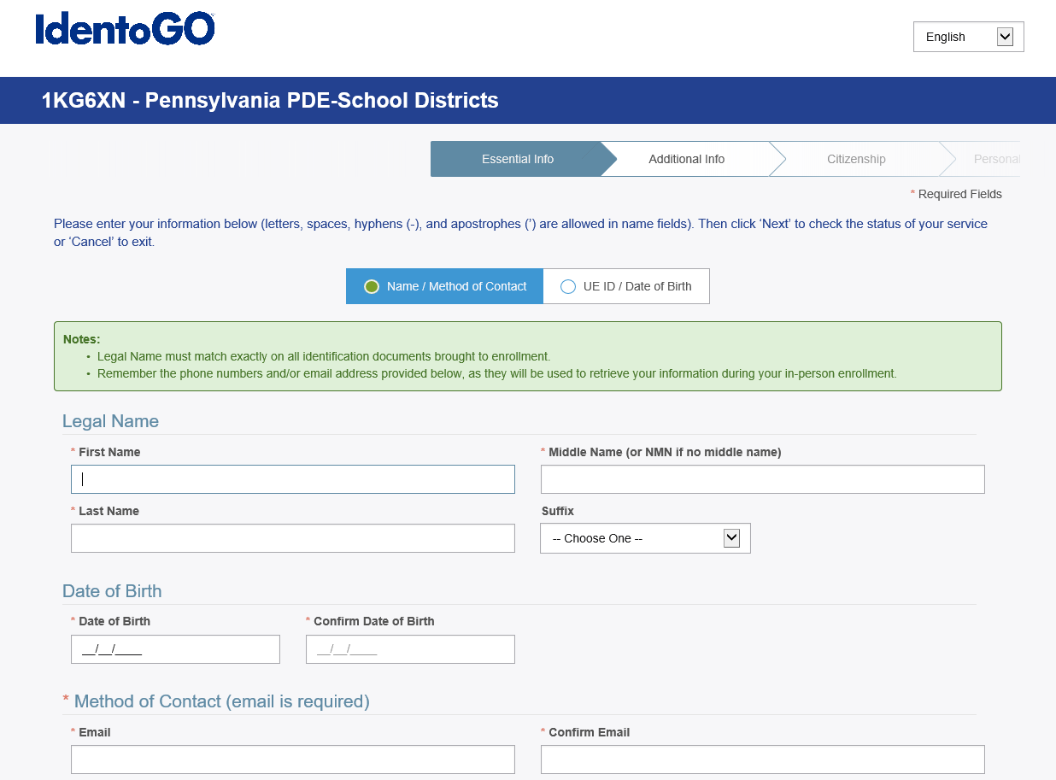

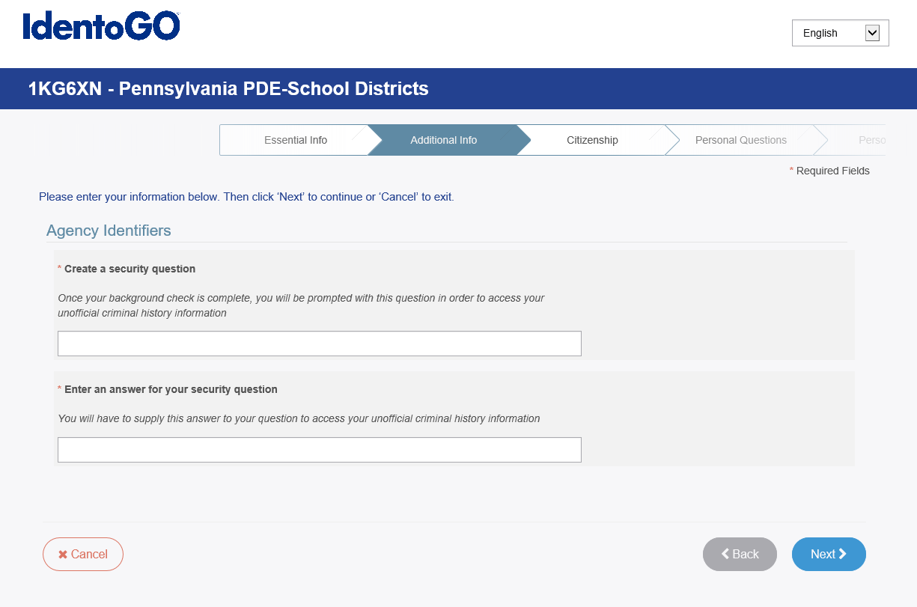

FBI FINGERPRINT CLEARANCE CONT.

1. Create a Security Question and Answer (notate for future reference)
2. Enter Citizenship Information
3. Enter answers to Personal Questions
4. Enter Personal Information

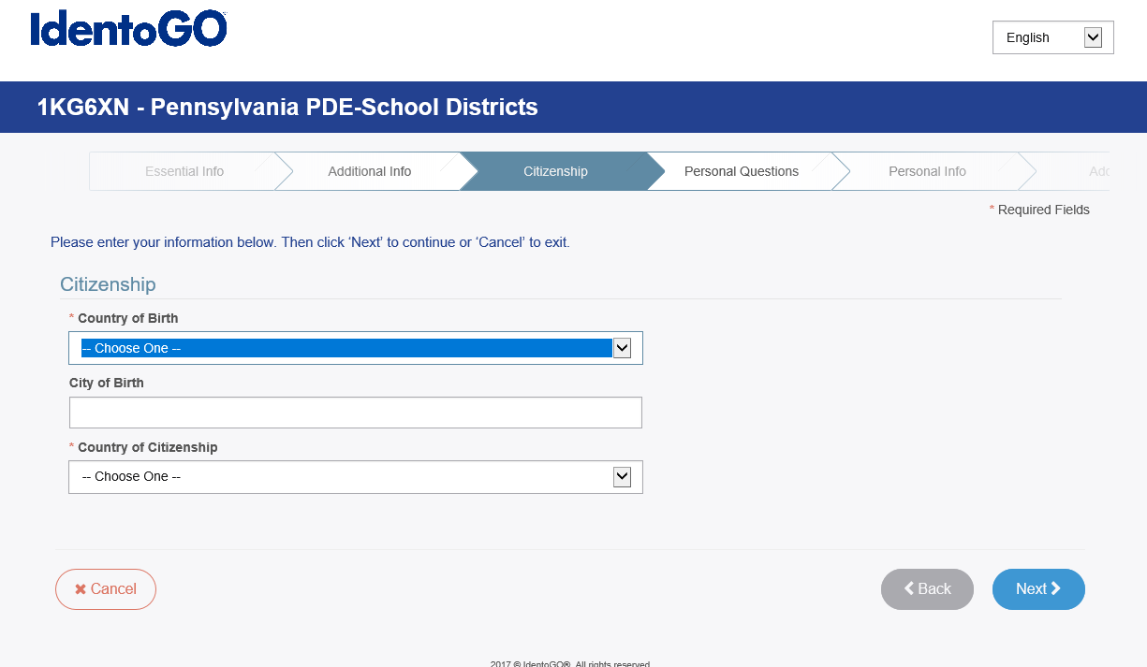

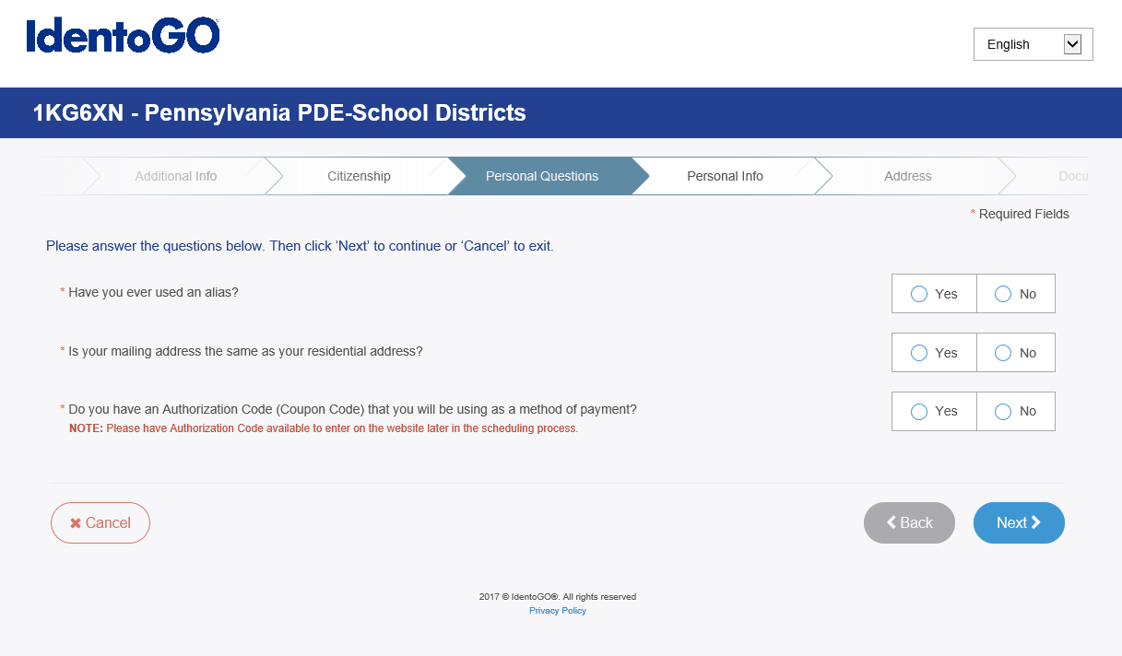

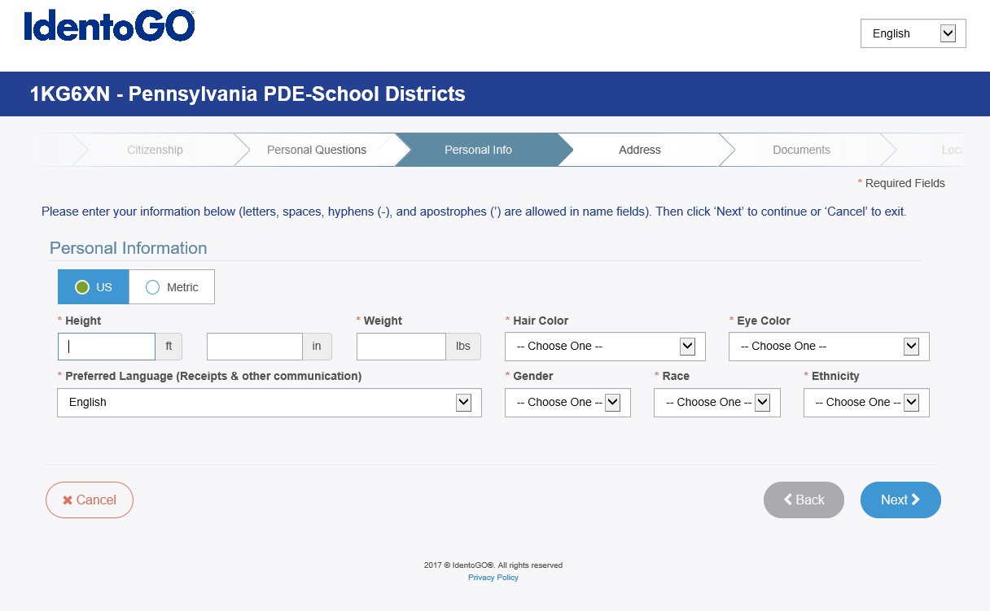

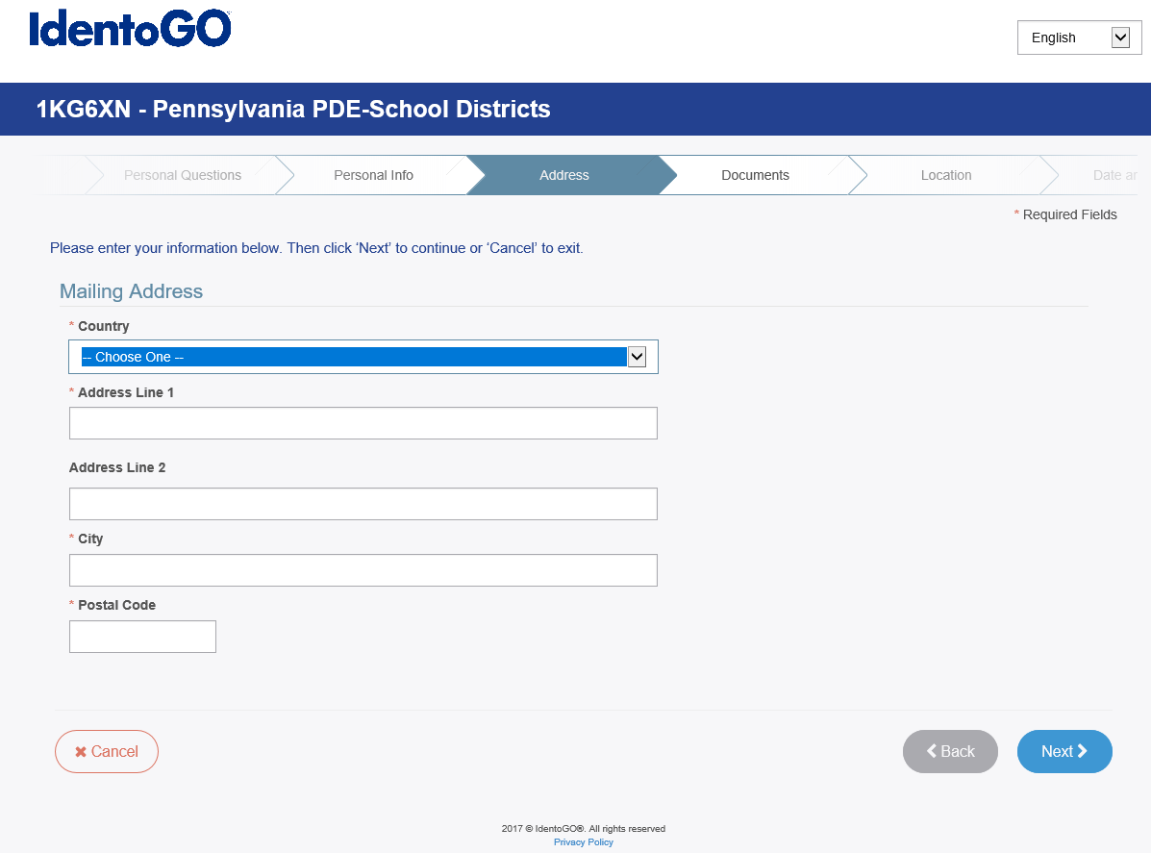

FBI FINGERPRINT CLEARANCE CONT.

10. Enter Address

1. Choose Document that you will bring with you for ID
2. Select Location
3. Schedule Appointment
4. Submit Registration
5. Print Confirmation
6. Payment is processed when prints are taken
7. Provide UEID to employer once prints have been processed

